DISTINCT W^{VI}O_{x} CONFIGURATIONS DISPERSED ON TITANIA.
TEMPERATURE AND COVERAGE EFFECTS.
Th. Kentri,^{a,b} A. Misa,ª A. Trimpalis,ª E. Korduli,^{c} and S. Boghosian*^{,a,b,d}
ª Department of Chemical Engineering, University of Patras, Patras, 26504, Greece;
^{b} FORTH/ICE-HT. Patras 26504, Greece;
^{c} Department of Chemistry, University of Patras, Patras 26504, Greece;
^{d} School of Science and Technology, Hellenic Open University, Patras, Greece
* bogosian@chemeng.upatras.gr
ABSTRACT
Titania supported tungsta constitute a class of materials widely used in environmental and industrial catalysis. To date, literature reports on the molecular structure of (WO_{x})_{n} sites dispersed on TiO₂ are far from being in consensus. Site configurations (i.e., mono-oxo vs di-oxo), wolfram coordination and aspects related to occurrence of multiple sites with distinct configurations remain open. Literature reports have often relied to one or two samples below monolayer coverage or to spectroscopic measurements after cooling the sample or to “fast” spectroscopic measurements, thereby suffering from one or more deficiencies.
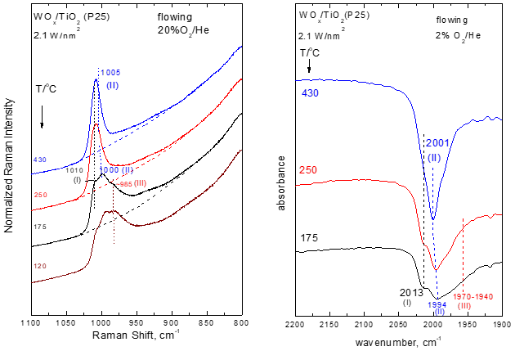
In the present work, all available tools of in situ molecular vibrational spectroscopy are deployed in the temperature range of 120 – 430ºC. In situ Raman spectroscopy complemented by in situ FTIR in the overtone spectral region and in situ Raman/¹⁸O isotope exchange measurements have been applied for probing the heterogeneity of the molecular structural configurations of W^{VI}O_{x} dispersed on titania. Incipient wetness impregnation was utilized to synthesize supported WO_{x}/TiO₂ catalysts on two variations of TiO₂ (P25 and anatase) at coverages up to the approximate monolayer (0.5 – 4.5 W/nm²). Moreover, results of neoteric Raman studies in sealed quartz cells under static equilibrium were exploited to cross-check the in situ findings, extended also in hydroxyl region of the spectra. Distinct WO_{x} site configurations (“Species-I”, “Species-II” and Species-III”) were identified, the prevalence of which is ruled by temperature and coverage. A reversible temperature-dependent molecular level mechanism mediated by water molecules retained on the support is proposed to account for the “Species-II” ↔ Species-III” transformation.
Hence, the current study addresses open questions regarding the prevalence of particular molecular WO_{x} structures deposited on titania and the heterogeneity of the dispersed WO_{x} phase on TiO₂.
KEYWORDS: tungsta/titania catalysts; dispersed phase configurations; in situ spectroscopy; temperature depen-dence; surface characteristics
Figure. Sequential in situ Raman and FTIR spectra obtained for 2.1 WO_{x}/TiO₂(P25) in order of decreasing temperatures. Evidence for occurrence of three distinct species [(I), (II) and (III)].

