ORR Reduction Mechanism, Kinetic Inertia and Energetics in HTPEMFCs
P.I. Giotakos^{1,2,*}, S.G.Neophytides^{1,**}
¹Foundation for Research and Technology Hellas, Institute of Chemical Engineering Sciences, 26504 Stadiou Str, Platani Rion, Greece
²Department of Chemical Engineering University of Patras, 26504 Rio Achaia, Greece
*pgiotakos@iceht.forth.gr
**neoph@iceht.forth.gr

High temperature polymer electrolyte (HTPEM) fuel cells, due to their high power efficiency and zero greenhouse emissions, constitute a promising candidate for green energy production. However their commercialization is severely hindered by the elusive and energy demanding Oxygen Reduction Reaction (ORR).
In order to elucidate and extract the ORR kinetics/energetics, initially a three step reaction mechanism was proposed (Figure 1) and a microkinetic transition state model was developed. The model was incorporated into an analytic macro-homogeneous 1D Transmission Line Model of the Cathode Catalyst Layer (CCL) for the simulation of both the steady state polarization curve (IV) and the intrinsic ORR impedance spectra. The experimental data (EIS and IV) were recorded at 180ºC, under differential conditions, with a 4cm² single serpentine cell, operating at the low current density (activation) regime, where ORR power losses are dominant and mass transport limitations negligible. For the parameter identification, an in house Monte Carlo regression algorithm was developed achieving both a unique solution and an excellent agreement with the experimental data.
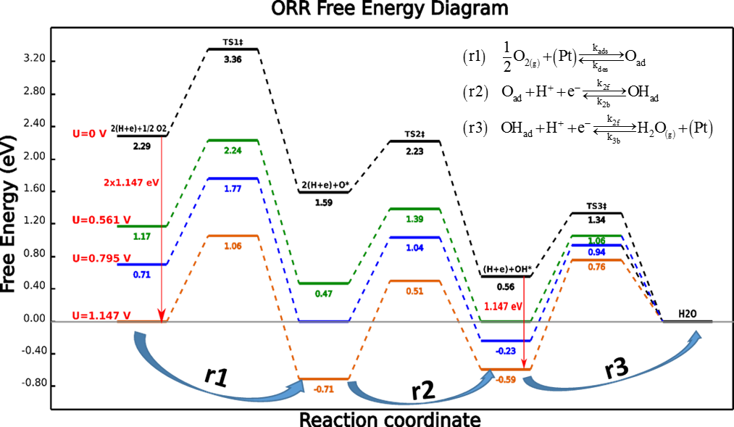
The analysis of the results demonstrated that: 1) the commonly used empirical Butler Volmer equation is inadequate to properly describe the experimental results, 2) the impedance spectra consist of a) a linear high frequency part caused by the finite H⁺ transport resistance in the CCL, b) a high frequency arc from both charge transfer reaction steps and c) a large low frequency arc from ORR’s “kinetic inertia”, due to the relaxation of the adsorbed surface reaction intermediates on the catalyst surface. 3) Regarding energetics, the high ORR overpotential losses stem from the combined strength of both kinetically and thermodynamically imposed barriers, specifically from: a) the high bonding strength of O_{ads} on Pt surface and b) the rather high activation energy of the O₂ adsorption step.
Figure 1. Free energy diagram of ORR on 30wt% Pt/C catalyst for several electrode potentials at standard state conditions, unit activities and 180ºC. The inset shows the proposed ORR pathway.

