MANIPULATION OF WATER DROPLETS ON POROUS SURFACES USING AIR PRESSURE AND ELECTRIC FIELDS

I. E. Markodimitrakis¹, N. Vourdas², A. G. Papathanasiou^{1,}*
¹ School of Chemical Engineering, NTUA, 15780, Athens, Greece
² Institute of Nanoscience & Nanotechnology, NCSR Demokritos, 15341, Athens, Greece
* pathan@chemeng.ntua.gr

ABSTRACT
The exploration of liquid actuation methodologies aiming to manipulate droplets without using mechanical parts is an important research challenge. The impact on various interdisciplinary applications, ranging from reduction of drag in maritime transport [1] to the handling of droplets on Lab-on-a-Chip self-diagnostic devices [2], is expected to be significant.
The present work outlines the proof-of-concept experiments on the actuation and mobility manipulation of water droplets by means of air pressure control [3] and electric fields [4]. The concept of actuation is achieved by tuning the solid/liquid adhesion upon voltage application on the one hand and providing the necessary energy for droplet sliding on the other via air pressure. Mobility switching of a water droplet on the inclined porous surface is achieved by direct air pressure application at the solid/liquid interface. When voltage is applied, droplet pinning is favored; electric stresses at the solid/liquid interface effectively adhere the liquid to the solid, creating an additional barrier that must be overcome by applying air pressure to move the droplet.
Ceramic gas-permeable porous specimens were manufactured and suitably modified for voltage application, and the droplet actuation and movement using electric fields and pressurized air through the surface pores was investigated. Our results showed that using this methodology reversible wetting modification can be achieved, while the actuation of droplet mobility on the inclined porous surface can be finely controlled.
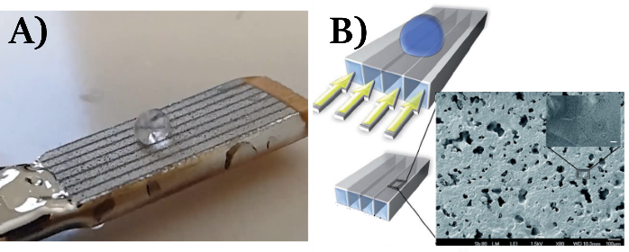
Figure 1 A) Snapshot of a water droplet on the porous media examined. B) Schematics of the porous media architecture for backpressure application and SEM image of the porous open surface.
KEYWORDS: droplet manipulation, actuation techniques, functional surfaces, electrowetting, pneumatic actuation

REFERENCES
[1] Yu, C., Liu, M., Zhang, C., Yan, H., Zhang, M., Wu, Q., Liu, M., & Jiang, L. (2020). Giant: 100017.
[2] Sohrabi, S., Kassir, N., & Moraveji, M. K. (2020). RSC Adv. 10 (46): 27560-27574.
[3] Vourdas, N., Pashos, G., Kokkoris, G., Boudouvis, A. G., Stathopoulos, V. N. (2016). Langmuir 32 (21): 5250-5258.
[4] Papathanasiou, A. G. (2018). Curr Opin Colloid Interface Sci., 36: 70-77.

