Green synthesis of graphene aerogels

G. Gorgolis^{1,#}, G. Paterakis², I. Sfougaris¹, N. Koutroumanis², B. Saner Okan^{3,4}, C.Galiotis^{1,2,*}
¹Department of Chemical Engineering, University of Patras
²Foundation for Research and Technology – Institute of Chemical Engineering Sciences
³Integrated Manufacturing Technologies Research and Application Center, Sabanci University
⁴NANOGRAFEN - Nanotechnological Products Chemistry R&D Consulting Industry and Trade Ltd.
(#ggorgolis@iceht.forth.gr, *c.galiotis@iceht.forth.gr)

Abstract
Graphene aerogels are three-dimensional light-weight scaffold materials which thanks to their remarkable properties like high mechanical strength and electrical conductivity, thermal resistance and adsorption capacity, have been immensely enriched [1]. The main routes for obtaining such materials are the hydrothermal reduction/self-assembly, chemical reduction, template-directed reduction, cross-linking and sol–gel processes while the main application fields regard water desalination and filtration/purification, energy storage [2] and environmental protection. But the main drawback for these materials which can slow down their widespread application is their high cost. The cost for synthesizing such materials is mainly increased from the carbon source which is graphene oxide (GO), for obtaining graphene aerogels. At the same time, there are plenty of carbonaceous sources to be exploited in order to assist in the synthesis of graphene-related (GRMs) materials. In that direction, NANOGRAPHENE, a spin off company of Sabanci University (SU), with production capacity of 500kg/month, starting from waste carbon black coming from the pyrolysis of waste-tires, are able to supply with Graphene-NanoPlatelets (GNPs) powder.
In this study, the successful synthesis of graphene aerogels using as carbon source the GO which has been obtained from the oxidation of the previously-mentioned GNPs powder, is reported. Aqueous solution of graphene oxide (GO) was diluted in water to obtain a concentration of 2 mg/mL. Hypophosphorous acid and iodine were then added as the chemically reducing agents. Subsequently the solution placed in a furnace and was heated to 80°C for 8 hours, resulting in a uniform gelation of the GO. The sample was then rinsed with water until a pH of equal to 7, followed by freeze-drying for 48 h. In the frames of the SOLAR-ERA.NET ‘GO-FOR-WATER’ project, Scanning Electron Microscopy, Raman microscopy and X-ray diffraction are used to characterize the produced graphene aerogels in University of Patras and FORTH, while the mechanical behaviour (i.e. static and dynamic compression) are also investigated by using micro-testing facilities already available at both institutions [3].

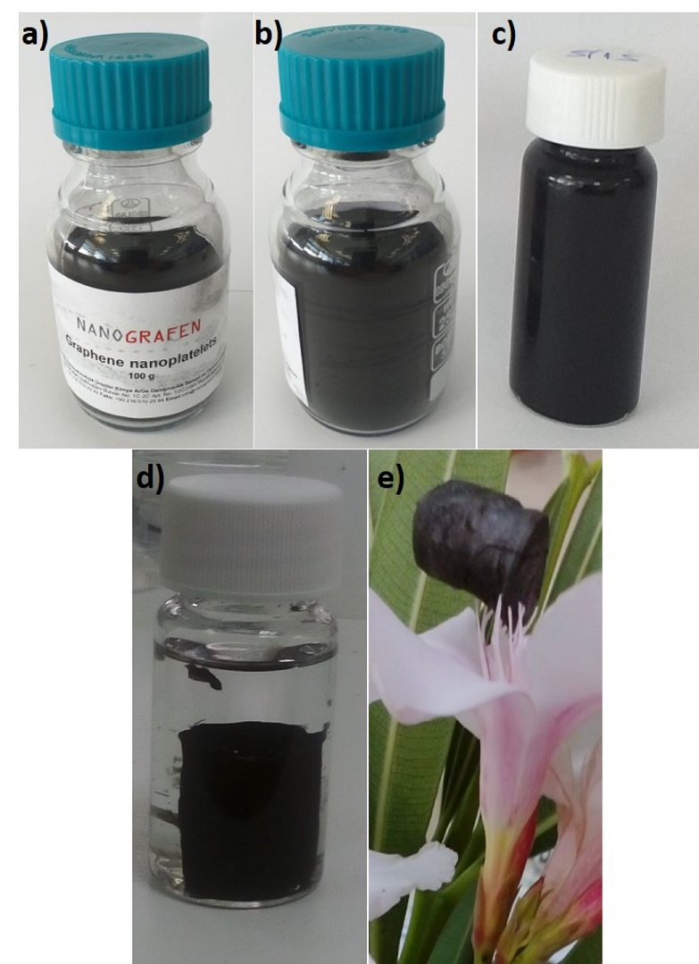
Figure: a), b) the used GNPs nanopowder, c) the as-obtained GO solution in water after the oxidation of the starting powder, d) the graphene hydrogel after the self-assembly of the reduced graphene oxide sheets, and, d) the corresponding graphene aerogel after the freeze-drying and sublimation of water.

REFERENCES
[1] G. Gorgolis and C. Galiotis, “Graphene aerogels: A review,” 2D Mater., vol. 4, no. 3, p. aa7883, 2017, doi: 10.1088/2053-1583/aa7883.
[2] M. Wu et al., “2020 Roadmap on Carbon Materials for Energy Storage and Conversion,” Chem. - An Asian J., vol. 15, no. 7, pp. 995–1013, 2020, doi: 10.1002/asia.201901802.
[3] C. Androulidakis et al., “Multi-functional 2D hybrid aerogels for gas absorption applications,” Sci. Rep., vol. 11, no. 1, p. 13548, 2021, doi: 10.1038/s41598-021-92957-8.

