The European Nanotechnology Community Informatics Platform: data and Machine Learning exploitation via the Enalos Chem/Nanoinformatics Cloud Platform

Antreas Tsoumanis¹, Dimitra-Danai Varsou¹, Georgia Melagraki², Anastasios G. Papadiamantis^{1,3}, Iseult Lynch³, Antreas Afantitis¹*
¹ NovaMechanics Ltd, Nicosia, Cyprus,
²Hellenic Army Academy, Athens, Greece
³School of Geography, Earth and Environmental Sciences, University of Birmingham,
Birmingham, UK
* afantitis@novamechanics.com

ABSTRACT
NanoCommons H2020 infrastructure project delivers a sustainable and openly accessible chem/nanoinformatics framework (knowledgebase and integrated computational tools, supported by expert advice, data interpretation and training), for the risk assessment of nanomaterials, their products and their formulations. NanoCommons (www.nanocommons.eu) is designed to provide innovative solutions for data mining, harmonisation, utilisation and re-utilisation, including incorporation of a range of modelling and decision support tools that require organised high-quality datasets on which to run, provided via an Open Access, federated Knowledge Commons platform. The Enalos Cloud Platform, developed by NanoCommons partner NovaMechanics, offers users a suite of services covering data processing and analysis, including deep learning techniques for the extraction of valuable descriptors from nanomaterials and the identification of hazardous effects invisible to the naked eye in organisms (e.g., Daphnia magna) from microscopy images. NanoCommons offers a wide suite of predictive modelling tools, based on machine learning algorithms, for nanomaterials toxicity, biological activity and properties evaluation, based on open source and in house developed algorithms. These tools can be combined with partner and external tools for safe by design and risk assessment to support the design and development of novel, safer and fully functional nanomaterials.
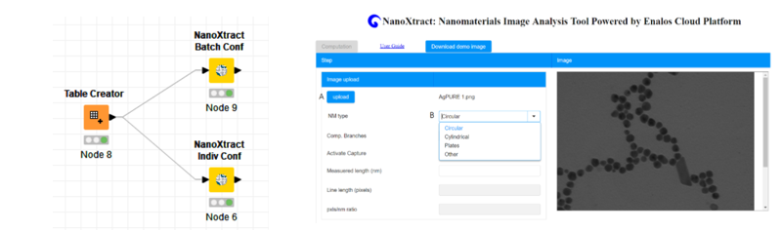

Fig1. NanoXtract Image Analysis Tool

The tools have been complemented with user-friendly interfaces and are available as web services through the Enalos Cloud Platform, integrated within the NanoCommons e-infrastructure project. In this way, the tools are available to the nano-community and its broadest set of stakeholders (enterprise, regulators, insurance and society broadly), either for independent use or with expert support as needed. Here, we present selected examples:
- the extraction of nanomaterials image descriptors from TEM images to enrich experimental descriptors and how these can be used to estimate the ζ-potential of other nanomaterials.
- Prediction of protein binding and cytotoxicity for functionalized MWCNTs (with small molecules)
- The use of predictive modelling for the analysis of the expression of genes profiling data obtained from carbon nanomaterials exposed cells.
- Integration of PBPK and exposure models for risk assessment of nanomaterials.
- Development of the extension of the InChI to represent nanomaterials to support harmonization and integration of datasets.
- Curated data ready for modelling through nanoPharos Database

Key words: data exploitation, transnational access, data enrichment, nanomaterials, Enalos platform

Acknowledgements
This work was funded by EU H2020 research infrastructure NanoCommons (grant agreement no. 731032)

