Isalos Analytics Platform: A Machine Learning / Artificial Intelligence Zero Code Solution for Chemical Engineering Applications
Dimitra-Danai Varsou, Andreas Tsoumanis, Anastasios Papadiamantis and Antreas Afantitis*
NovaMechanics Ltd, Nicosia, Cyprus,
* afantitis@novamechanics.com

ABSTRACT
Nanomaterials (NMs) The growing trend of employing machine learning and data analysis methods in various disciplines and sectors that are not strongly associated to informatics (e.g., marketing, social sciences), requires the use of algorithms by individuals or professionals who in many cases lack deep programming skills. Thus, there is a need to access and utilize these techniques through easy-to-use, and intuitive environments, which at the same time offer access to powerful computing tools without the need for code development. The Isalos Predictive Analytics Platform addresses these needs, as it offers a plethora of ready-to-use, well-known machine learning methods without the need of any coding skills. These methods can be implemented through a user-friendly and easy-to-learn graphical interface. In this chapter we present and discuss, with the aid of case studies, the main features of the Isalos platform to facilitate data analysis and modelling. We aspire that by the end of this chapter, the reader will perceive the efficiency of the platform, and its versatility to their own data analysis and machine learning requirements.

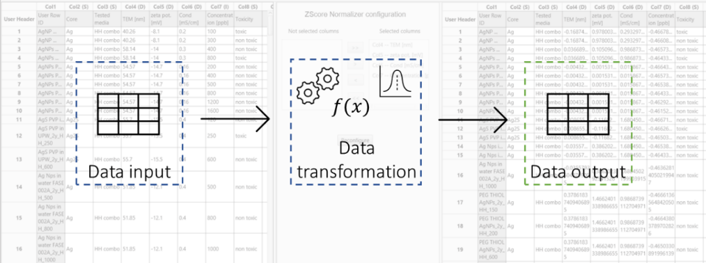
Fig. 1 Operational concept of Isalos platform. Isalos tabs act like nodes, where data are imported and exported in tabular format. In between they are processed and transformed using specific functions.

KEYWORDS: Machine Learning, Artificial Intelligence, Zero Code, Analytics

ACKNOWLEDGMENT
This work received funding from the European Union's Horizon 2020 research and innovation programme via NanoSolveIT, NanoCommons, CompSafeno ands Sabydoma Projects

REFERENCES
[1] Papadiamantis AG, Afantitis A, Tsoumanis A, et al (2021) Computational enrichment of physicochemical data for the development of a ζ-potential read-across predictive model with Isalos Analytics Platform. NanoImpact 22:100308. https://doi.org/10.1016/j.impact.2021.100308
[2] Papadiamantis AG, Jänes J, Voyiatzis E, et al (2020) Predicting cytotoxicity of metal oxide nanoparticles using isalos analytics platform. Nanomaterials 10:1–19. https://doi.org/10.3390/nano10102017

