Estimation of Dielectric Permittivity for Additively Manufactured Non-homogeneous RF Substrates
H. Kiani¹, D. Chatzichristodoulou^{1,2}, S. Nikolaou¹, DD. Varsou³, G. Melagraki³, A. Afantitis^{3,}*
¹ 7, Y. Frederickou Str., Pallouriotisa, Nicosia 1036, Cyprus, Frederick University
² 12, Kallitheas Str., Dromolaxia 7020, Cyprus, RF and Microwave Solutions Ltd
³ Digeni Akrita 51, 1070, Novamechanics Ltd
* afantitis@novamechanics.com
ABSTRACT
The control over the dielectric permittivity of a RF substrate can open up new ways of developing RF & microwave components. Additive manufacturing of composite substrates can be pivotal towards this end. However, the characterization of these 3D printed, multilayered composite substrates in terms of dielectric permittivity and loss tangent can be a challenging and time-consuming task. In this paper, we present a hybrid method for the estimation of dielectric permittivity of a composite additively manufactured substrate using a simple microstrip ring resonator and full wave simulations. The initial guess is made with the simulation data and then the S-parameters of the 3D printed substrate are measured with a VNA. The measured results are then compared with the already simulated results and a new set of simulations is performed to match the measured results. In this way, a fast and accurate estimation of the dielectric permittivity of the 3D printed substrate can be easily made.

KEYWORDS: Additive manufacturing, ring resonator, material characterization

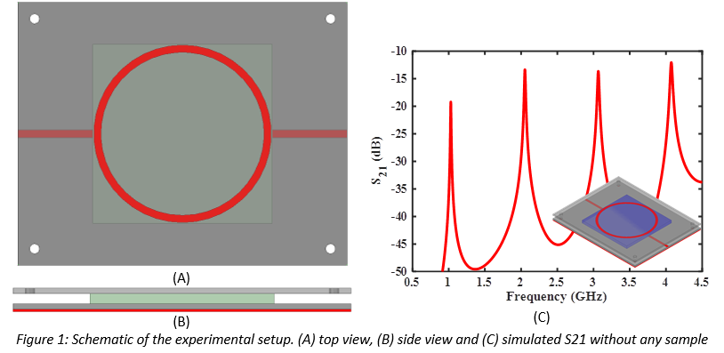

ACKNOWLEDGMENT
This work received funding from the European Union's Horizon 2020 research and innovation programme via AMABLE Project under grant agreement number 768775.

