Morphological Transformations of Ag Nanoparticles via Molecular Dynamics Simulations

E. Voyiatzis¹, A. G. Papadiamantis^{1,2}, G. Melagraki³, E. Valsami-Jones², A. Afantitis¹*
¹ NovaMechanics Ltd., Nicosia 1065, Cyprus
² School of Geography and Environmental Sciences, University of Birmingham, Birmingham, B15 2TT, UK
³ Division of Physical Sciences and Applications, Hellenic Military Academy, Vari, 16673, Greece
* afantitis@novamechanics.com

ABSTRACT
The diverse functionality of nanomaterials due to their small size have led to their use in multiple applications. These include consumer products, wearables, personal devices, applications in industry and construction and more. Their unique properties are due to either quantum effects, which become prominent at the nanoscale, and/or due to their high surface to volume ratio. Out of the wide range of different nanomaterials chemistries, Ag nanomaterials are among the most widely used, due to their antibacterial properties. On the other hand, their dissolution and the release of Ag ions has led to suggestions that they may be toxic, either due to the combined particle/ion effect or due to ionic Ag only. Furthermore, the dissolution of Ag nanomaterials and the reprecipitation of larger particles or other phases leads to structural transformations that has a pronounced effect on their properties and behaviour. We present here the atomistic molecular dynamics simulations of Ag nanoparticles (NPs) in vacuum. Starting at the atomic level and fundamental Ag nanomaterial characteristics we predict their morphological transformations, which can lead to changes in their physicochemical response. Their structural modifications are studied as a function of atom-based particle size at substantially higher resolutions compared to current experimental feasibility. This work enables the alignment between effects taking place at the nanoscale and specific nanomaterials activity, and considers how these morphology transformations help our understanding of potential toxicity and/or environmental impact of nanomaterials.

KEYWORDS: Ag, nanoparticles, nanodescriptors, molecular simulations

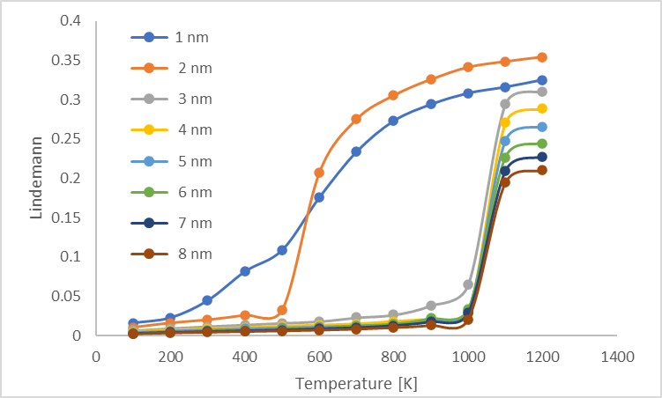
Figure 1: Variation of the Berry parameter with temperature for Ag NPs.
ACKNOWLEDGEMENTS
This work has been supported by the SABYDOMA project which has received funding from the European Union’s HORIZON 2020 Research & Innovation Programme under grant agreement no. 862296.

