ΤΙΤΛΟΣ (ΚΕΦΑΛΑΙΑ, ΜΕΓΕΘΟΣ 12, CALIBRI)

Α. Επώνυμο^{1,2}, Α. Επώνυμο¹, Α. Β. Επώνυμο ², Επώνυμο^{1,}* (Calibri 12)
¹ Στοιχεία Διεύθυνσης 1, Affiliation 1, (Calibri M12, Ελληνικά ή Αγγλικά
² Στοιχεία Διεύθυνσης 2, Affiliation 2, (Calibri M12, Ελληνικά ή Αγγλικά
* Email address of the corresponding author

ΠΕΡΙΛΗΨΗ (Calibri 12) (Μέγιστος αριθμός λέξεων 350)
Κείμενο-Κείμενο- Κείμενο-Κείμενο- Κείμενο-Κείμενο- Κείμενο-Κείμενο- Κείμενο-Κείμενο- Κείμενο
Π.χ.
The offshore wind (OFW) industry is one of the most rapidly advancing sources of power around the world. It makes sense: Wind is stronger and more consistent over the open ocean than it is on land. Some wind farms are capable of powering 500,000 homes or more. Currently, Europe leads the market, making up almost 80% of OFW capacity. However, the worldwide demand for energy is expected to increase by 20% in 10 years, with a large majority of that demand supplied by sustainable energy sources like wind power.

ΛΕΞΕΙΣ ΚΛΕΙΔΙΑ: Λέξη, Φράση, Λέξη (Calibri 10, Μέχρι 5 λέξεις/φράσεις)

1. ΕΙΣΑΓΩΓΗ (Calibri 12) (max 1.5 σελίδα)
Κείμενο-Κείμενο- Κείμενο-Κείμενο- Κείμενο-Κείμενο- Κείμενο-Κείμενο- Κείμενο-Κείμενο- Κείμενο
The offshore wind (OFW) industry is one of the most rapidly advancing sources of power around the world. It makes sense: Wind is stronger and more consistent over the open ocean than it is on land. Some wind farms are capable of powering 500,000 homes or more. Currently, Europe leads the market, making up almost 80% of OFW capacity. However, the worldwide demand for energy is expected to increase by 20% in 10 years, with a large majority of that demand supplied by sustainable energy sources like wind power. The offshore wind (OFW) industry is one of the most rapidly advancing sources of power around the world. It makes sense: Wind is stronger and more consistent over the open ocean than it is on land. Some wind farms are capable of powering 500,000 homes or more. Currently, Europe leads the market, making up almost 80% of OFW capacity. However, the worldwide demand for energy is expected to increase by 20% in 10 years, with a large majority of that demand supplied by sustainable energy sources like wind power.

2. ΜΕΘΟΔΟΛΟΓΙΑ (Calibri 12) (max 2 σελίδες)
Κείμενο-Κείμενο- Κείμενο-Κείμενο- Κείμενο-Κείμενο- Κείμενο-Κείμενο- Κείμενο-Κείμενο- Κείμενο
The offshore wind (OFW) industry is one of the most rapidly advancing sources of power around the world. It makes sense: Wind is stronger and more consistent over the open ocean than it is on land. Some wind farms are capable of powering 500,000 homes or more. Currently, Europe leads the market, making up almost 80% of OFW capacity. However, the worldwide demand for energy is expected to increase by 20% in 10 years, with a large majority of that demand supplied by sustainable energy sources like wind power. The offshore wind (OFW) industry is one of the most rapidly advancing sources of power around the world. It makes sense: Wind is stronger and more consistent over the open ocean than it is on land. Some wind farms are capable of powering 500,000 homes or more. Currently, Europe leads the market, making up almost 80% of OFW capacity. However, the worldwide demand for energy is expected to increase by 20% in 10 years, with a large majority of that demand supplied by sustainable energy sources like wind power. The offshore wind (OFW) industry is one of the most rapidly advancing sources of power around the world. It makes sense: Wind is stronger and more consistent over the open ocean than it is on land. Some wind farms are capable of powering 500,000 homes or more. Currently, Europe leads the market, making up almost 80% of OFW capacity. However, the worldwide demand for energy is expected to increase by 20% in 10 years, with a large majority of that demand supplied by sustainable energy sources like wind power. The offshore wind (OFW) industry is one of the most rapidly advancing sources of power around the world. It makes sense: Wind is stronger and more consistent over the open ocean than it is on land. Some wind farms are capable of powering 500,000 homes or more. Currently, Europe leads the market, making up almost 80% of OFW capacity. However, the worldwide demand for energy is expected to increase by 20% in 10 years, with a large majority of that demand supplied by sustainable energy sources like wind power. The offshore wind (OFW) industry is one of the most rapidly advancing sources of power around the world. It makes sense: Wind is stronger and more consistent over the open ocean than it is on land. Some wind farms are capable of powering 500,000 homes or more. Currently, Europe leads the market, making up almost 80% of OFW capacity. However, the worldwide demand for energy is expected to increase by 20% in 10 years, with a large majority of that demand supplied by sustainable energy sources like wind power.

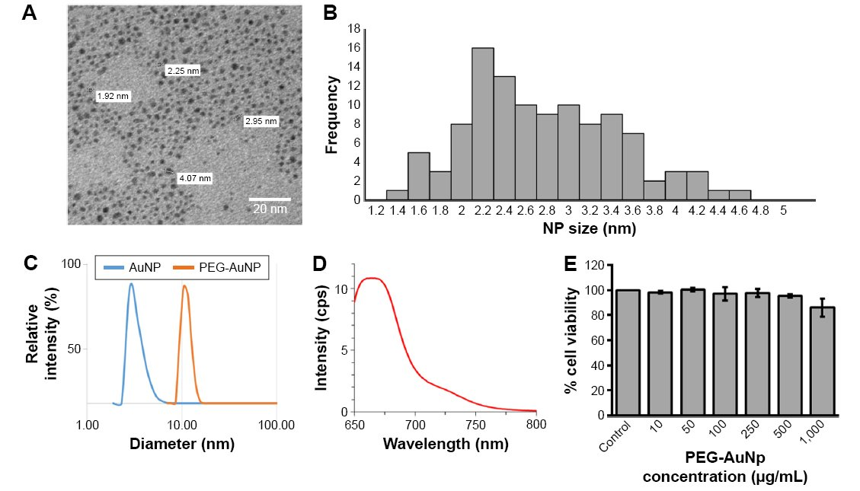
Σχήμα 1: Σχηματική αναπαράσταση της πειραματικής μεθοδολογίας. (A) φωτογραφία του πορώδους μέσου, (B) επίδραση του μεγέθους των νανοσωματιδίων στην Συχνότητα. (Calibri Italics 10).

3. ΑΠΟΤΕΛΕΣΜΑΤΑ & ΣΥΖΗΤΗΣΗ (Calibri 12) (max 2 σελίδες)
Κείμενο-Κείμενο- Κείμενο-Κείμενο- Κείμενο-Κείμενο- Κείμενο-Κείμενο- Κείμενο-Κείμενο- Κείμενο
The offshore wind (OFW) industry is one of the most rapidly advancing sources of power around the world. It makes sense: Wind is stronger and more consistent over the open ocean than it is on land. Some wind farms are capable of powering 500,000 homes or more. Currently, Europe leads the market, making up almost 80% of OFW capacity. However, the worldwide demand for energy is expected to increase by 20% in 10 years, with a large majority of that demand supplied by sustainable energy sources like wind power.

Πίνακας 1: Επίδραση της Παραμέτρου 1 στη Μεταβλητή 1, Μεταβλητή 2 … (Calibri Italics 10)
Title 1 | Title2 | Title3 | Title4

ΑΝΑΦΟΡΕΣ
[#] Author(s). (Year). Journal title abbreviation - Italics. Volume(issue):location. (Calibri 10, En)
Π.χ.
[1] Taylor, T., & Hood, W. (2020). J. Comp. Mech. 87 (20): 2200-2245.

