TITLE (UPPER CASE, SIZE 12, CALIBRI)

Initial of First Name. Last Name^{1,2}, Initial of First Name. Last Name², Initial of First Name. Last Name^{1,}* (Calibri 12)
¹ Mail Address 1, Affiliation 1, (Calibri M12, English)
² Mail Address 1, Affiliation 1, (Calibri M12, English)
* Email address of the corresponding author

ABSTRACT (Calibri 12) (Max # words 350)
Text – Text – Text – Text – Text
The offshore wind (OFW) industry is one of the most rapidly advancing sources of power around the world. It makes sense: Wind is stronger and more consistent over the open ocean than it is on land. Some wind farms are capable of powering 500,000 homes or more. Currently, Europe leads the market, making up almost 80% of OFW capacity. However, the worldwide demand for energy is expected to increase by 20% in 10 years, with a large majority of that demand supplied by sustainable energy sources like wind power.

KEYWORDS: Keyword1, Keyword2 (Calibri 10, Up to 5 Keywords)

1. INTRODUCTION (Calibri 12) (max 1.5 pages)
Text – Text – Text – Text – Text
The offshore wind (OFW) industry is one of the most rapidly advancing sources of power around the world. It makes sense: Wind is stronger and more consistent over the open ocean than it is on land. Some wind farms are capable of powering 500,000 homes or more. Currently, Europe leads the market, making up almost 80% of OFW capacity. However, the worldwide demand for energy is expected to increase by 20% in 10 years, with a large majority of that demand supplied by sustainable energy sources like wind power. The offshore wind (OFW) industry is one of the most rapidly advancing sources of power around the world. It makes sense: Wind is stronger and more consistent over the open ocean than it is on land. Some wind farms are capable of powering 500,000 homes or more. Currently, Europe leads the market, making up almost 80% of OFW capacity. However, the worldwide demand for energy is expected to increase by 20% in 10 years, with a large majority of that demand supplied by sustainable energy sources like wind power.

2. METHODOLOGY (Calibri 12) (max 2 pages)
Text – Text – Text – Text – Text
The offshore wind (OFW) industry is one of the most rapidly advancing sources of power around the world. It makes sense: Wind is stronger and more consistent over the open ocean than it is on land. Some wind farms are capable of powering 500,000 homes or more. Currently, Europe leads the market, making up almost 80% of OFW capacity. However, the worldwide demand for energy is expected to increase by 20% in 10 years, with a large majority of that demand supplied by sustainable energy sources like wind power. The offshore wind (OFW) industry is one of the most rapidly advancing sources of power around the world. It makes sense: Wind is stronger and more consistent over the open ocean than it is on land. Some wind farms are capable of powering 500,000 homes or more. Currently, Europe leads the market, making up almost 80% of OFW capacity. However, the worldwide demand for energy is expected to increase by 20% in 10 years, with a large majority of that demand supplied by sustainable energy sources like wind power. The offshore wind (OFW) industry is one of the most rapidly advancing sources of power around the world. It makes sense: Wind is stronger and more consistent over the open ocean than it is on land. Some wind farms are capable of powering 500,000 homes or more. Currently, Europe leads the market, making up almost 80% of OFW capacity. However, the worldwide demand for energy is expected to increase by 20% in 10 years, with a large majority of that demand supplied by sustainable energy sources like wind power. The offshore wind (OFW) industry is one of the most rapidly advancing sources of power around the world. It makes sense: Wind is stronger and more consistent over the open ocean than it is on land. Some wind farms are capable of powering 500,000 homes or more. Currently, Europe leads the market, making up almost 80% of OFW capacity. However, the worldwide demand for energy is expected to increase by 20% in 10 years, with a large majority of that demand supplied by sustainable energy sources like wind power. The offshore wind (OFW) industry is one of the most rapidly advancing sources of power around the world. It makes sense: Wind is stronger and more consistent over the open ocean than it is on land. Some wind farms are capable of powering 500,000 homes or more. Currently, Europe leads the market, making up almost 80% of OFW capacity. However, the worldwide demand for energy is expected to increase by 20% in 10 years, with a large majority of that demand supplied by sustainable energy sources like wind power.

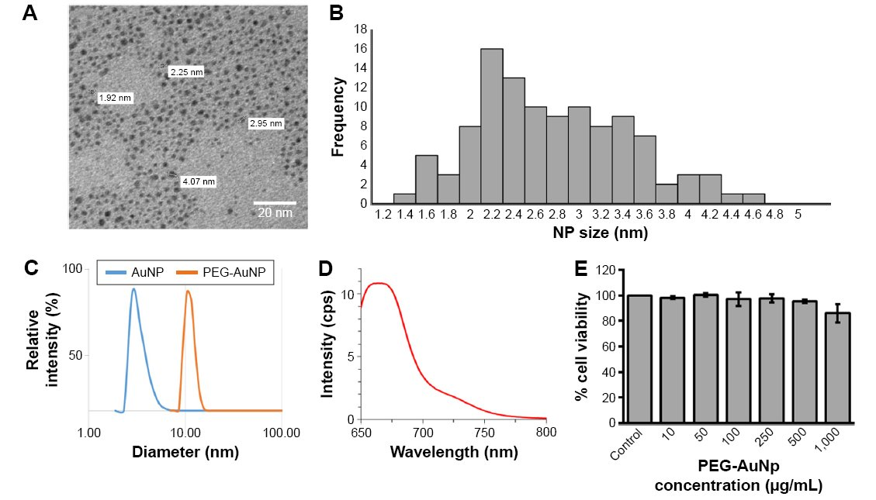
Figure 1: Schematic of the experimental methodology. (A) photograph of the porous medium, (B) effect of the NP size on the frequency (Calibri Italics 10).

3. RESULTS & DISCUSSION (Calibri 12) (max 2 pages)
Text – Text – Text – Text – Text
The offshore wind (OFW) industry is one of the most rapidly advancing sources of power around the world. It makes sense: Wind is stronger and more consistent over the open ocean than it is on land. Some wind farms are capable of powering 500,000 homes or more. Currently, Europe leads the market, making up almost 80% of OFW capacity. However, the worldwide demand for energy is expected to increase by 20% in 10 years, with a large majority of that demand supplied by sustainable energy sources like wind power.

Table 1: Effect of Parameter 1 on Variable 1, Variable 2 … (Calibri Italics 10)
Title 1 | Title2 | Title3 | Title4

REFERENCES
[#] Author(s). (Year). Journal title abbreviation - Italics. Volume(issue):location. (Calibri 10, En)
[1] Taylor, T., & Hood, W. (2020). J. Comp. Mech. 87 (20): 2200-2245.

